EXECUTIVE SUMMARY

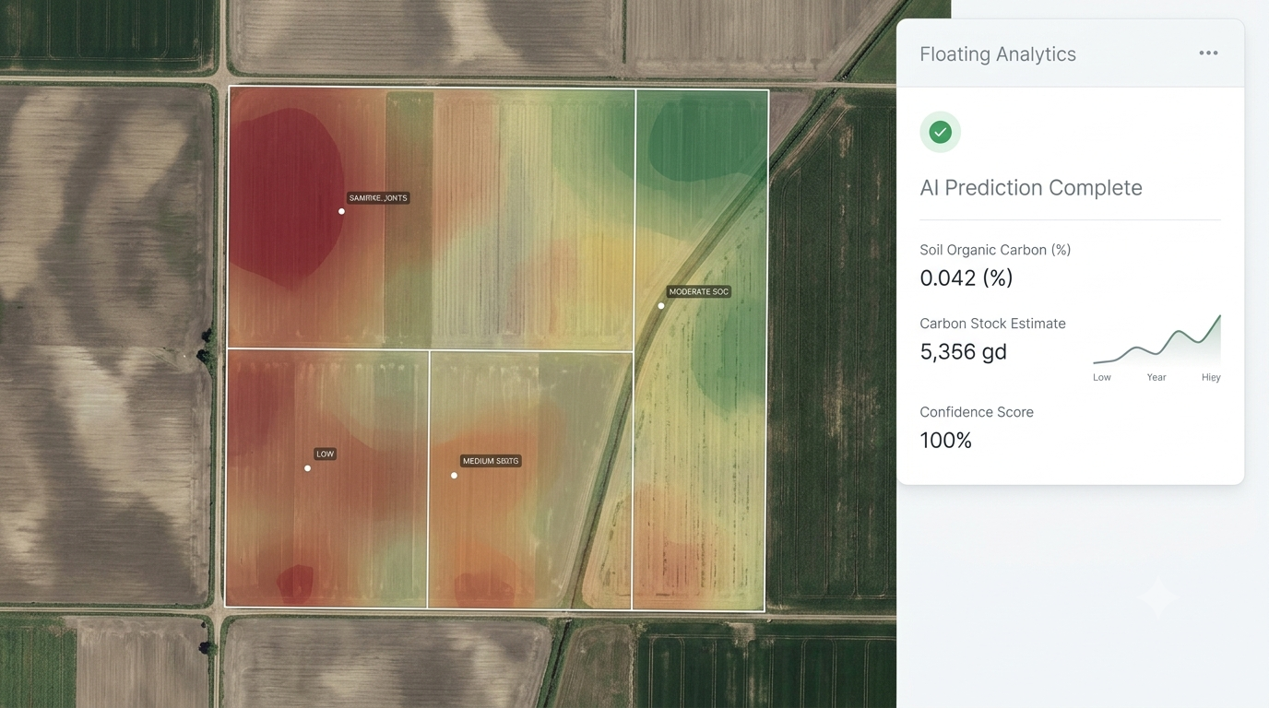

VARIA Carbon

AI-Based Soil Carbon Estimation for Carbon MRV

The Challenge
Accurate soil carbon measurement is essential for carbon projects, but conventional laboratory sampling is expensive, time-consuming, and difficult to scale across large landscapes.
Project developers often need a practical way to identify priority areas, estimate baseline soil carbon, and support early-stage project planning before investing in extensive field campaigns.

The Solution
VARIA Carbon is an AI-powered decision-support tool that rapidly estimates Soil Organic Carbon (SOC%) using readily available environmental data.
Inputs include:
- NDVI (Satellite Imagery)
- Annual Precipitation
- Mean Annual Temperature
- Elevation
- Clay Content
The platform generates:
- Estimated Soil Organic Carbon (SOC%)
- Carbon stock estimation
- Spatial visualization
- Exportable results for further analysis
VARIA Carbon is designed as a rapid estimation tool to complement—not replace—field sampling and laboratory analysis.

Technical Overview
Proof-of-concept model developed and validated using the EU LUCAS Soil Dataset.
Performance:
- R² = 0.78
- MAE = 0.80% SOC
- Low overfitting (train/test performance difference <0.15)
The current version demonstrates the feasibility of AI-assisted soil carbon estimation for large-scale screening and project planning.

Why VARIA Carbon
- AI-assisted estimation in seconds
- No field visit required for initial assessment
- Scalable across large project areas
- Deployable on your own infrastructure
- Complete source code included
- REST API for integration
- Docker-based deployment
- Transparent workflow (no black-box SaaS)

Potential Applications
- Early-stage Carbon MRV
- Baseline soil carbon assessment
- Project area prioritization
- Soil health monitoring
- Sustainable agriculture planning
- Research and education

Current Status
VARIA Carbon is currently available as a working prototype demonstrating the core prediction workflow.
The platform is actively evolving toward a more comprehensive decision-support system for soil carbon and carbon project developers.

Contact
Mahdieh Kazemi
AI Engineer | Environmental Data & Machine Learning
Email:
mah.kzmi21@gmail.com
Demo:
https://varia-carbon.streamlit.app

